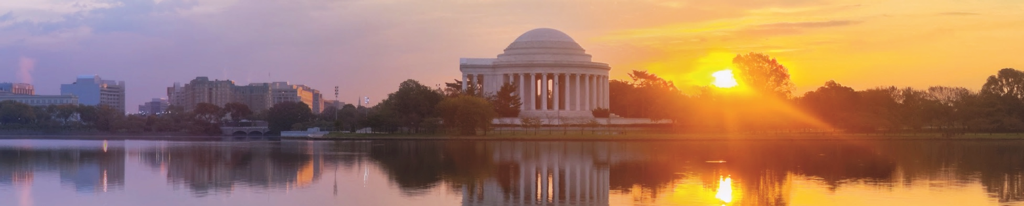











DAY 1
Arrive in Washington, D.C.
Meet your WorldStrides representative and begin your once-in-a-lifetime experience!
Arlington National Cemetery America’s most famous military cemetery: Changing of the Guard, Tomb of the Unknown Soldier, Kennedy Gravesites
US Marine Corp War Memorial A tribute to all U.S. Marines based on the famous WWII photo by Joe Rosenthal
9/11 Pentagon Memorial Honors the 184 victims of the 9/11 attack at the Pentagon
Dinner and hotel check-in
DAY 2
Breakfast
Alexandria One of America's oldest and most historic cities
Mount Vernon George Washington’s home, plantation, and Education Center, which showcases life during colonial times, 18th-century treasures, and our first president as a farmer and businessman
Lunch
Capitol Hill Grounds Tour (by appointment) Capitol Visitor Center, Supreme Court, Library of Congress
National Archives (by appointment) Home of the original Constitution, Bill of Rights, and Declaration of Independence
Dinner
DAY 3
Breakfast
Lincoln Memorial In remembrance of former President Abraham Lincoln and the great nation he fought to preserve during the Civil War
Vietnam Veterans Memorial Dedicated to the more than 58,000 men and women killed or missing in Vietnam
Korean War Veterans Memorial Tribute to the men and women who defended South Korea in the Korean War
Lunch
Smithsonian Institution The world's largest museum complex: National Air and Space Museum, National Museum of Natural History, Smithsonian American Art Museum / National Portrait Gallery, National Museum of American History, National Museum of African American History and Culture (by appointment)
Dinner
FDR Memorial In remembrance of former President Franklin Delano Roosevelt
Jefferson Memorial Dedicated to our third president and author of the Declaration of Independence
DAY 4
Breakfast
Washington Monument (picture stop) The world’s tallest stone monument, which honors our nation’s first president
World War II Memorial Honors the 16 million who served — and 400,000 who died — in the U.S. Armed Forces during WWII, and all who supported the war effort from home
MLK Memorial Honors the famous civil rights activist, Martin Luther King, Jr.
Lunch
Holocaust Museum (by appointment) The museum provides documentation, study, and interpretation of Holocaust history.
Kennedy Center A magnificent performing arts center dedicated to our 35th president
Dinner
DAY 5
Breakfast and hotel check-out
White House (picture stop) Home of the U.S. president
Ford’s Theatre and Petersen House (by appointment) Where President Lincoln was shot and later died on that fateful day
Embassy Row Houses more than 170 foreign embassies
Tour of the National Cathedral (by appointment)
Lunch
National Zoo Home to several giant pandas and more!
Dinner
Depart Washington, D.C., for home

WASHINGTON, D.C.
DEPART DATE: XX/XX/XXXX
RETURN DATE: XX/XX/XXXX
TRIP PRICE: $ X,XXX

HD5 - 5 4 DC
The above represents a sample itinerary. Changes or substitutions may be made depending on your travel dates, arrival and departure times, national holidays, and events beyond WorldStrides’ control at the discretion of WorldStrides as it deems necessary or desirable.
YOUR DAY-BY-DAY ADVENTURE
ACADEMIC CREDIT
EXPERTLY TRAINED COURSE LEADERS
HOTEL
ACCOMMODATIONS
TRANSPORTATION TO / FROM ALL ACTIVITIES
THREE MEALS DAY
(UNLESS OTHERWISE STATED)
24-HOUR
EMERGENCY SUPPORT
ROUND TRIP
TRANSPORTATION
ADMISSIONS & FEES FOR SCHEDULED ACTIVITIES
AN ALL-INCLUSIVE EXPERIENCE

