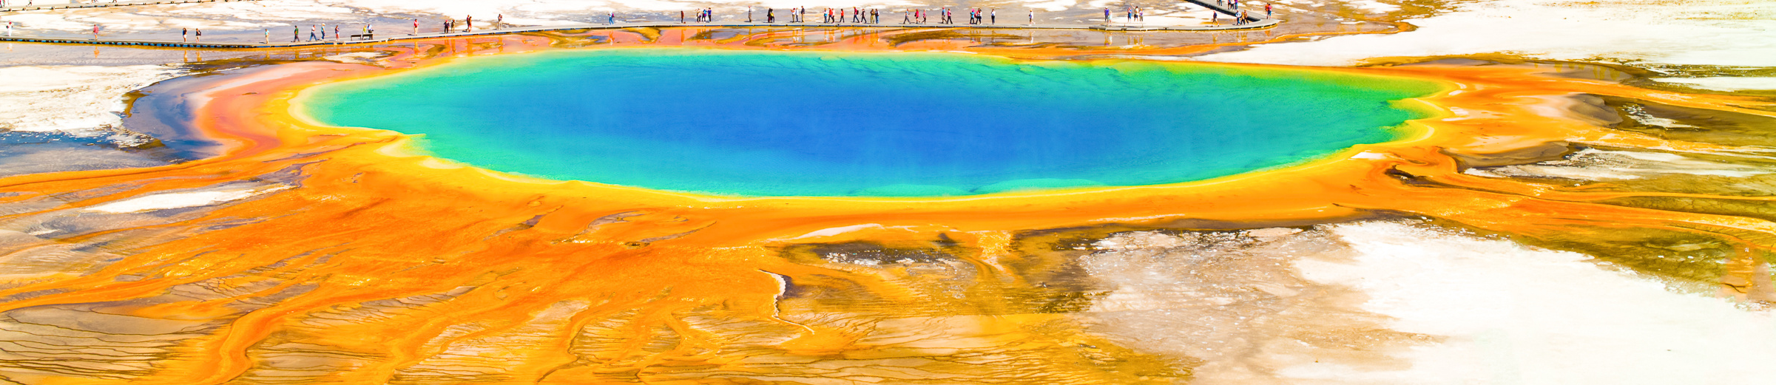

Stop at Colter Bay for a scenic lunch and photo op! Students can stroll the rocky shoreline, collect memories of the driftwood-strewn beach, and capture breathtaking shots of the Teton Range, featuring the massive peak of Mount Moran reflecting off the crystal-clear water.
DAY 1
Arrive Salt Lake City, UT
Lunch
Travel to Idaho Falls, ID
Lava Hot Springs visit Soak in the world-famous Lava Hot Springs! Students can relax in geothermal pools ranging from 102° to 112°, all fueled by natural underground springs. They’ll explore the Sunken Gardens to spot local birds in a serene, volcanic landscape.
Dinner
Hotel check-in and Orientation

DAY 2
Breakfast and hotel check-out
travel to Jackson, WY
Jackson Square walking tour – CL led Experience the Old West at Jackson Town Square! Students will walk under iconic elk antler arches, browse Western-themed shops, and visit the Veterans Memorial. They'll see a nightly historical shootout reenactment bringing the frontier to life.
Lunch
Snake River Float
Relax on a scenic Snake River float as students drift through pristine habitats, spot bald eagles, moose, and elk, and learn about the region’s ecology and history with expert guides.
Dinner
Snow King Mountain Scenic Gondola
Ride the Snow King Mountain Scenic Gondola nearly 1,600 feet to the summit, where students enjoy a comfortable ascent and sweeping 360-degree views of the Grand Tetons, National Elk Refuge, and Jackson below.
Snow King Observatory & Planetarium evening show
Ascend to the summit for a stellar experience. Students use a 1-meter telescope to view galaxies and planets, then enjoy planetarium shows exploring the solar system and supermassive black holes.
Hotel check-in

DAY 3
Hotel check-out and breakfast
Travel to Grand Teton National Park
Jenny Lake Visitor Center
Visit the historic Harrison Crandall Studio at the Jenny Lake Visitor Center. Students explore the park’s artistic heritage while enjoying panoramic views of Teewinot Mountain and Cascade Canyon in the Teton Range.
Jenny Lake shuttle boat
Glide across crystal-clear Jenny Lake on a scenic shuttle boat ride. Surrounded by Teton peaks, students enjoy glacial views, spot shoreline wildlife, and begin their alpine adventure.
Hidden Fall and Inspiration Point hike - CL led
After crossing Jenny Lake by boat, students hike to 100-foot Hidden Falls to study hydrology and forest ecology, then climb to Inspiration Point for panoramic valley views and lessons on glacial geology and alpine ecosystems.
Lunch & Colter Bay picture stop
Stop at Colter Bay for a scenic lunch and photo opportunity. Students stroll the rocky shoreline, enjoy the driftwood-strewn beach, and photograph stunning Teton views with Mount Moran reflected in the clear water.
Travel to Yellowstone National Park
West Thumb Geyser Basin visit
Explore West Thumb Geyser Basin, where geothermal features meet Yellowstone Lake. Students see Abyss Pool and Fishing Cone while learning about hydrothermal ecosystems and the park’s volcanic history.
Canyon Village visit
Marvel at the Grand Canyon of Yellowstone as students view the 308-foot Lower Falls from Artist Point, experience the Upper Falls, and explore the colorful canyon carved by powerful geological forces.
Dinner
hotel check-in
DAY 4
Breakfast
Enter Yellowstone National Park
Norris Geyser Basin visit
Marvel at the Grand Canyon of Yellowstone as students view the 308-foot Lower Falls from Artist Point, experience the Upper Falls, and explore the colorful canyon carved by powerful geological forces.

Lower Geyser Basin visit
Explore the Fountain Paint Pot area to see all four hydrothermal features. Students observe bubbling mud pots, colorful hot springs, and steaming vents while learning how heat, acidity, and microbes shape the landscape.
Midway Geyser Basin visit (time permitting)
Witness Grand Prismatic Spring, the world’s third-largest hot spring. Students marvel at its 370-foot expanse and colorful rings formed by thermophiles while exploring Midway Geyser Basin.
Lunch
Upper Geyser Basin visit
Explore the world’s largest concentration of geysers in the Upper Geyser Basin. Students walk scenic boardwalks to view eruptions, then visit the Old Faithful Visitor Center to learn about Yellowstone’s volcanic science.
Mammoth Hot Springs and Historic Fort Yellowstone visit
Explore Mammoth Hot Springs as students walk boardwalks past steaming, colorful terraces. Then visit Historic Fort Yellowstone to tour Army-era barracks and learn about the military’s role in protecting the park.
Dinner
Free time in West Yellowstone
DAY 5
Breakfast and hotel checkout
Return to Yellowstone National Park
Lamar Valley visit
Experience the “Serengeti of North America” in Lamar Valley. Students view herds of bison, watch for wolves, and explore lush meadows along the Lamar River for premier wildlife viewing.
Lunch
Leave Yellowstone through Gardiner to Bozeman, MT
Depart for home from Bozeman MT
Dinner
Yellowstone and Grand Tetons Landscapes and Nature in 5 days
ST5e - 5 4 Habitat
YOUR DAY-BY-DAY ADVENTURE

